For 70 years, Charles River employees have worked together to assist in the discovery, development and safe manufacture of new drugs. We are passionate about our role in improving the quality of people’s lives. Our mission, our excellent science, and our strong sense of purpose guide us in all that we do. We approach each day with the knowledge that our work helps to improve the health and well-being of many across the globe and you have a chance to do that at a new Insourcing Solutions (IS) location. Our collective efforts as One Charles River are the key to our success, and we know that every employee is important. We are committed to empowering our employees with the tools and programs they need to develop rewarding and fulfilling career development. Career development comes with new opportunities and the Insourcing Solutions development offer that opportunity to you in Houston, Texas. If you have been wanting to grow into a new role, Here’s your chance! Wanting to move from a higher cost of living and colder climate to the sunny south Texas and a lower cost of living in many surrounding Houston areas…. Here’s your chance!

The Charles River IS Division is partnering with Baylor College of Medicine’s Center for Comparative Medicine department to staff several positions from entry level to leadership roles (listed below). These positions can be viewed at www.criver.com/careers; please view and apply for any opportunity that may bring you to further development opportunities within CRL Insourcing Solutions to fulfill your career goals. Apply through Talent Hub-Careers or network and refer your friends. The referral bonus still applies!

Senior Supervisor and Supervisor
Animal Care Technicians (levels 1,2,3 and 4/Lead)
Cagewash Technicians 1, 2 and Cagewash Lead

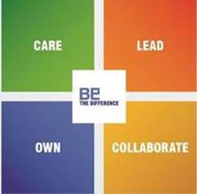

Equal Employment Opportunity
Charles River Laboratories, Inc. is an Equal Opportunity Employer M/F/Disabled/Vet

